Terms | Autumn 1 | Autumn 2 | Spring 1 | Spring 2 | Summer 1 | Summer 2
Year 2 Themes | Animals Including humans | Light | Fun with Materials | Recycle, renew, recreate | Living things and their habitats | Protecting Our World
RE – Come and See | Beginnings  Signs & Symbols | Signs & Symbols (cont.)  World Religion -  Judaism  Preparations | Books  Feast of St. Timothy  Thanksgiving | Thanksgiving (cont.)  Opportunities | Spread the Word  Rules | Rules (cont.)  World Religions - Islam  Feast of St. Peter and St. Paul  CAFOD: Treasures
Personal, Social and Health Education (PSHE) including:  Relationship, Sex & Health Education (RSHE) | Created and Loved by God |  | Created to Love others |  | Created to Live in a Community
English:  Spoken Language, Reading & Writing | Main Text  Little Red by Bethan Woolvin.  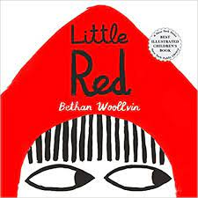 | Main Text  Little Glow by Katie Sahota  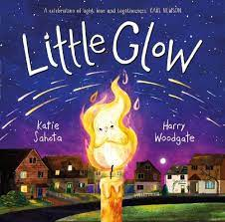 | Main Text  Stuck by Oliver Jeffers  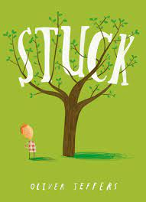 | Main Text  Nen and the Lonely Fisherman  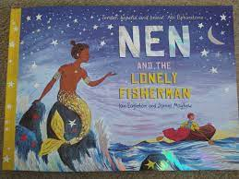 | Main Text  Nature’s Tiny Miracle: Bee by Patricia Hegarty  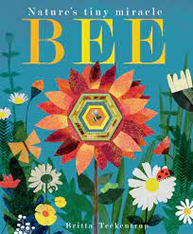 | Main Text  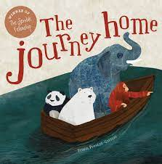  The Journey Home by Fran Preston-Gannon
English:  Storytime- short novel | The Diary of a Killer Cat by Anne Fine | How Winston came Home for Christmas by Alex T Smith | The Twits by Roald Dahl | The Hodgeheg by Dick King-Smith | The Sandman and the Turtles by Michael Morpurgo | The Hundred Mile an Hour Dog by Jeremy Strong
Maths | Block 1 – Place Value | Block 2 – Addition and Subtraction  Block 3 - Shape | Block 4 – Money  Block 5 – Multiplication and Division | Block 5 – continued  Block 6 – Length and Height  Block 7 - Mass, Capacity and temperature | Block 8 - Fractions  Block 9 - Time | Block 10 - Statistics  Block 11 - Position and Direction  Consolidation
Mastering Number | Consolidate recall of number bonds within 10; they will re-cap the composition of the numbers 11 to 20 and reason about their position within the linear number system. |  | Use knowledge of composition of numbers within 10 to calculate within 20; explore links between the numbers in the linear number system within 10 to numbers within 100, focusing on multiples of 10 and the midpoint of 50. |  | Use knowledge of the composition of numbers within 10 to calculate within 20 and to reason about equations and inequalities.
Science | Animals including humans |  | Uses of everyday materials: |  | Living Things and their habitats – plants and animals
Computing | Explore how computer games work. |  | Open, compose and send an email. |  |  | Collect data and organise digital content.
History |  | Guy Fawkes  Changes in Technology |  | Compare Mary Seacole/Florence Nightingale with Kitty Wilkinson | Great Fire of London link with materials and where come from
Geography | United Kingdom and its capital cities |  |  | Weather Patterns |  | Kenya - Nairobi
 | Identify seasonal and daily weather patterns
Art & Design |  | The artist Andy Warhol |  | David Edgar – Recycled Art |  | Aboriginal Art
DT | Vegetables. Preparing a healthy meal |  | Puppets |  | Levers and sliders
P.E.  Gymnastics and Dance | Gymnastics -  Parts high and low | Dance (cc music) | Dance - Around the World | Gymnastics - Pathways straight, zig zag | Gymnastics - Linking movements together. | Athletics and team games
 | Swimming lessons
Sports and Games | Throwing, catching, inventing games. | Throwing, catching, inventing games.  (continued) | Making games with a partner -aiming, hitting, kicking | Dribbling, kicking and hitting. | Group Games and Inventing Rules | Athletics and team games
Music | Tony Chestnut – beat, rhythm, pitch and echo | Carnival of the animals/ Magical musical aquarium-timbre, tempo, dynamics, pitch and classical music | Grandma up – duration, unison, round | Orawa – beat, rhythm, structure, 20th century classical music | Swing a long with Shostakovich – mood, tempo, dynamics and rhythm | Tanczymy Labada -duration and chords
 |  |  | Recorder Lessons
Spanish | Greetings, body parts, animals | Numbers to 30, Christmas words | Shapes, materials | Numbers up to 50 in tens, plants/vegetables | Numbers up to 50  Animals & habitats | Days of the week, months of the year,  Summer

