Term Dates | Autumn 1 | Autumn 2 | Spring 1 | Spring 2 | Summer 1 | Summer 2
Year 1  Themes | Myself &  Animals | Where do we belong? | Materials | Space | Fruit | Plants
RE – Come and See | Families  Belonging | Belonging (cont.)  World Religions: Judaism  Waiting | Special People  23rd January:  Feast of St. Timothy  Meals | Meals (cont.)  Change | Holidays & Holydays  Being Sorry | Being Sorry (cont.)  World Religions: Islam  29th June:  Feast of  St. Peter & St. Paul  CAFOD: Neighbours
RSHE – Relationship and Sex Education  PSHEE – Personal, Social, Health, Emotional & Economic Education | Created and Loved by God |  | Created to Love Others |  | Created to Live in Community
English:  Spoken Language, Reading & Writing | 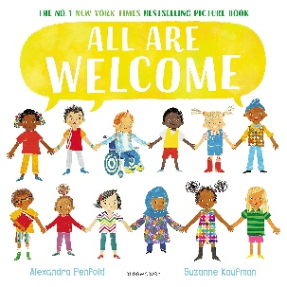  Main Text  All are welcome - Alexandra Penfold | Main Text  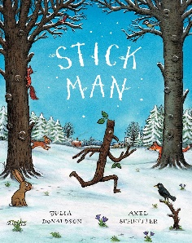  Stick Man – Julia Donaldson | Main Text  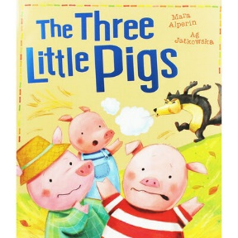  Traditional Tale – The Three Little Pigs | Main Text  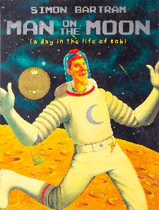  ‘Man on the Moon’ by Simon Bartram  ‘Mae Among the Stars’ | Main Text  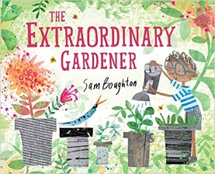  The Extraordinary Gardener – Sam Boughton | Main Text  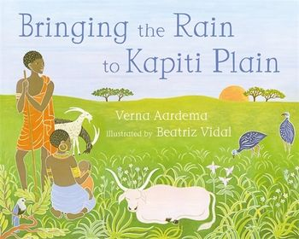  Bringing the Rain to Kapiti Plain – Verna Aardema
Mathematics | Block 1 - Number and place value to 10 | Block 2 – Addition and subtraction (within 10) | Block 4 - Place Value to 20.  Block 5 - Addition and Subtraction to 20. | Block 8 - Place Value to 50 | Block 9 - Multiplication and division.  Block 10 - Fractions | Block 12 - Place Value to 100
 |  | Block 3 - Shape | Block 6 – Length & Height | Block 7 – Mass & Volume | Block 11 – Position and Direction | Block 12 – Money  Block 13 - Time
Mastering Number | Consolidate the ELG.  Composition of numbers within 10. Position these numbers in the linear number system. |  | Continue to explore the composition of numbers within 10.  Explore addition and subtraction structures and the related language (without the use of symbols). |  | Explore the composition of numbers within 20.  Connect addition and subtraction expressions and equations to ‘number stories’.
Science | Animals including humans |  | Materials |  | Plants
Computing | Programming - using beebots |  |  | Creating videos using a digital device |  | Information Technology – searching the internet, creating a digital book.  Online Safety
History |  | Toys in the 1960s | Why was there a castle in West Derby? |  | The Coronation
Geography |  | West Derby – our local area |  | Weather reporting |  | Continents and Oceans
 | Weather and the Seasons – ongoing throughout the year
Art & Design | Self – Portrait assessment piece  Artist - Mark Powell |  |  | Artist – Asya Kozina | Artist - Georgia O’Keefe
DT |  | Wheels & axels | Free Standing Structures |  |  | Fruit & Vegetables
Music | Menu Song | Colonal Hathi’s march.  Magical Musical Aquarium  Nativity songs | Football | ‘Dawn’ from the Sea Interludes  Musical Conversations | Dancing and drawing to Nautilus  Cat and Mouse  Moving On | As I was walking down the street
PE  Gymnastics & Dance | Gymnastics – Flight, Bouncing, Jumping and landing | Dance –  Seasons | Gymnastics - Points and patches | Dance –  Space | Gymnastic - Rocking and Rolling | Gymnastics –  Wide-narrow-curled
Sports & Games | Ball Skills and Games | Throwing and catching aiming games | Bat and ball skills and games | Developing Partner Work | Athletics and Games
Spanish | Greetings  Numbers | Parts of the Body Animals | Materials | Plants | Fruit | Seasons

